**Kaleeva Alina**

**Junior Manual QA Engineer**

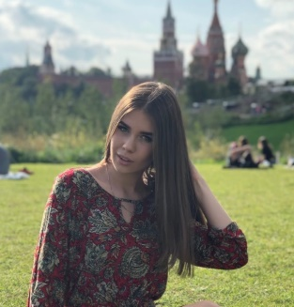**Personal info:**

**City:** Minsk

**Birth Date**: 07.06.2001

**Phone number**: 80(44)7330367

**E-mail**: [Kaleeva.fam@gmail.com](mailto:Kaleeva.fam@gmail.com)

**Linkedin**: <https://www.linkedin.com/in/alina-kaleeva-82a051207/>

**Website:** <https://kaleevaalina.github.io/QA_resume/>

**Work experience:**

6 months of work in the company «Scrump dedicated team» in manual QA position.

**Main tools:**

* Knowledge of QA methodologist. Good understanding of testing approaches and practices:

- Function and Non-functional testing;

- Conducting integration testing;

- Maintaining test documentation;

- UI/UX testing;

- Test Case/Checklist/ Bug Report;

* Strong experience in manual functional testing: black-box, component and integration testing, positive, negative testing, cross-browser and cross-platform testing, GUI, regression testing, smoke testing, exploratory testing
* Understanding Verification and Validation;
* Interaction with development departments;
* Familiar with HTML , CSS:
* Basic knowledge in SQL;
* Knowledge of client-server applications with principles(HTTP, HTTPS, REST, SOUP);
* Requirements analysis
* Problem solving
* Experience in testing mobile and web applications
* Analytical mind and good problem-solving skills
* Team work
* Experience working by Kanban methodology
* Testing API

**Technical skills:**

* OS platform: MS Windows, MacOS, iOS, Android
* Bug Tracking Tools: Jira, Trello, Intasker

**Core competencies:**   
Functional testing, Web applications testing, Mobile testing, Test

Documentation, Test Design Techniques

**Education:**

* High Education: Belarusian State Economic University 2018-2022-Specialization: foreign economic activity;
* QA courses from It Academy STORMNET 2021;
* Beonmax - Web development(HTML, CSS) 2020-2021;
* IT SHATLE - Web development(HTML, CSS) 2020-2021.

**About me:**

**My strengths:** Responsibility and accurate

Fast learner;

Self-motivated;

Self-organizing work style;

Good communication skills.